TEST CASES EXECUTED

1. POST METHOD TEST CASES

* With valid input JSON

Response status – 201 – created

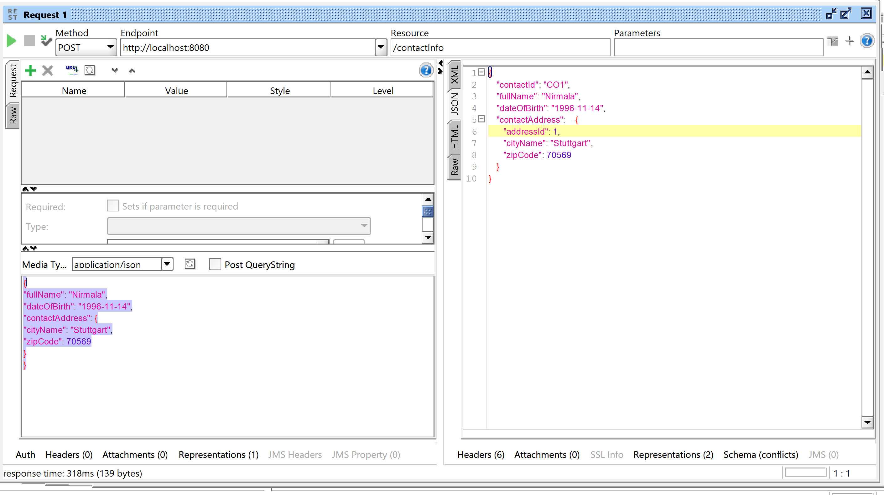

* Invalid date provided in JSON

Response status 400 Bad Request

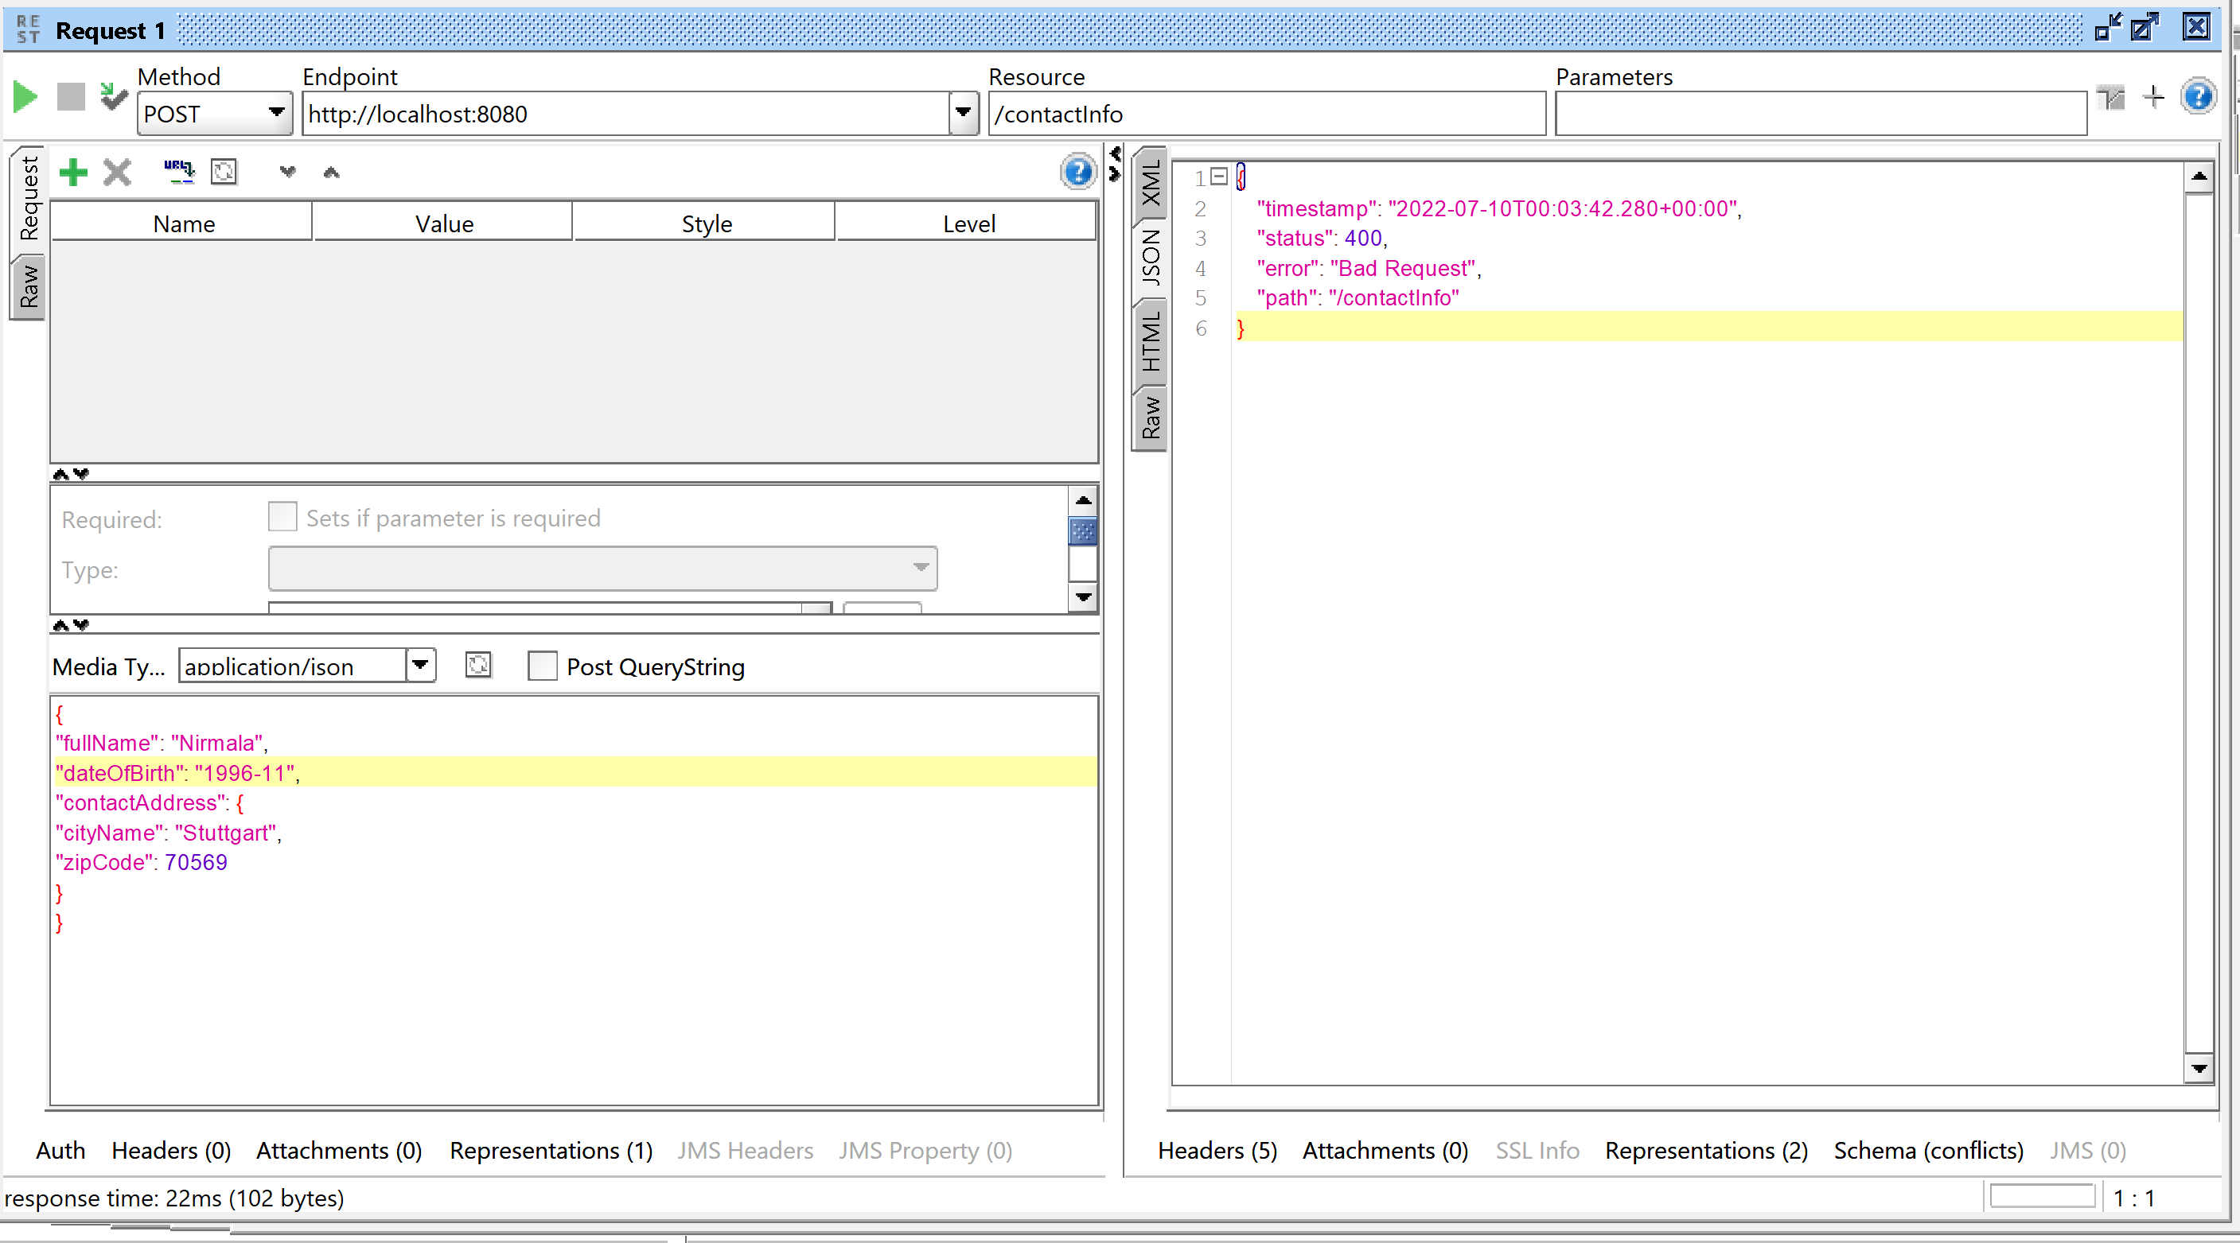

GET REQUEST

Valid request

Response status - 200- Success

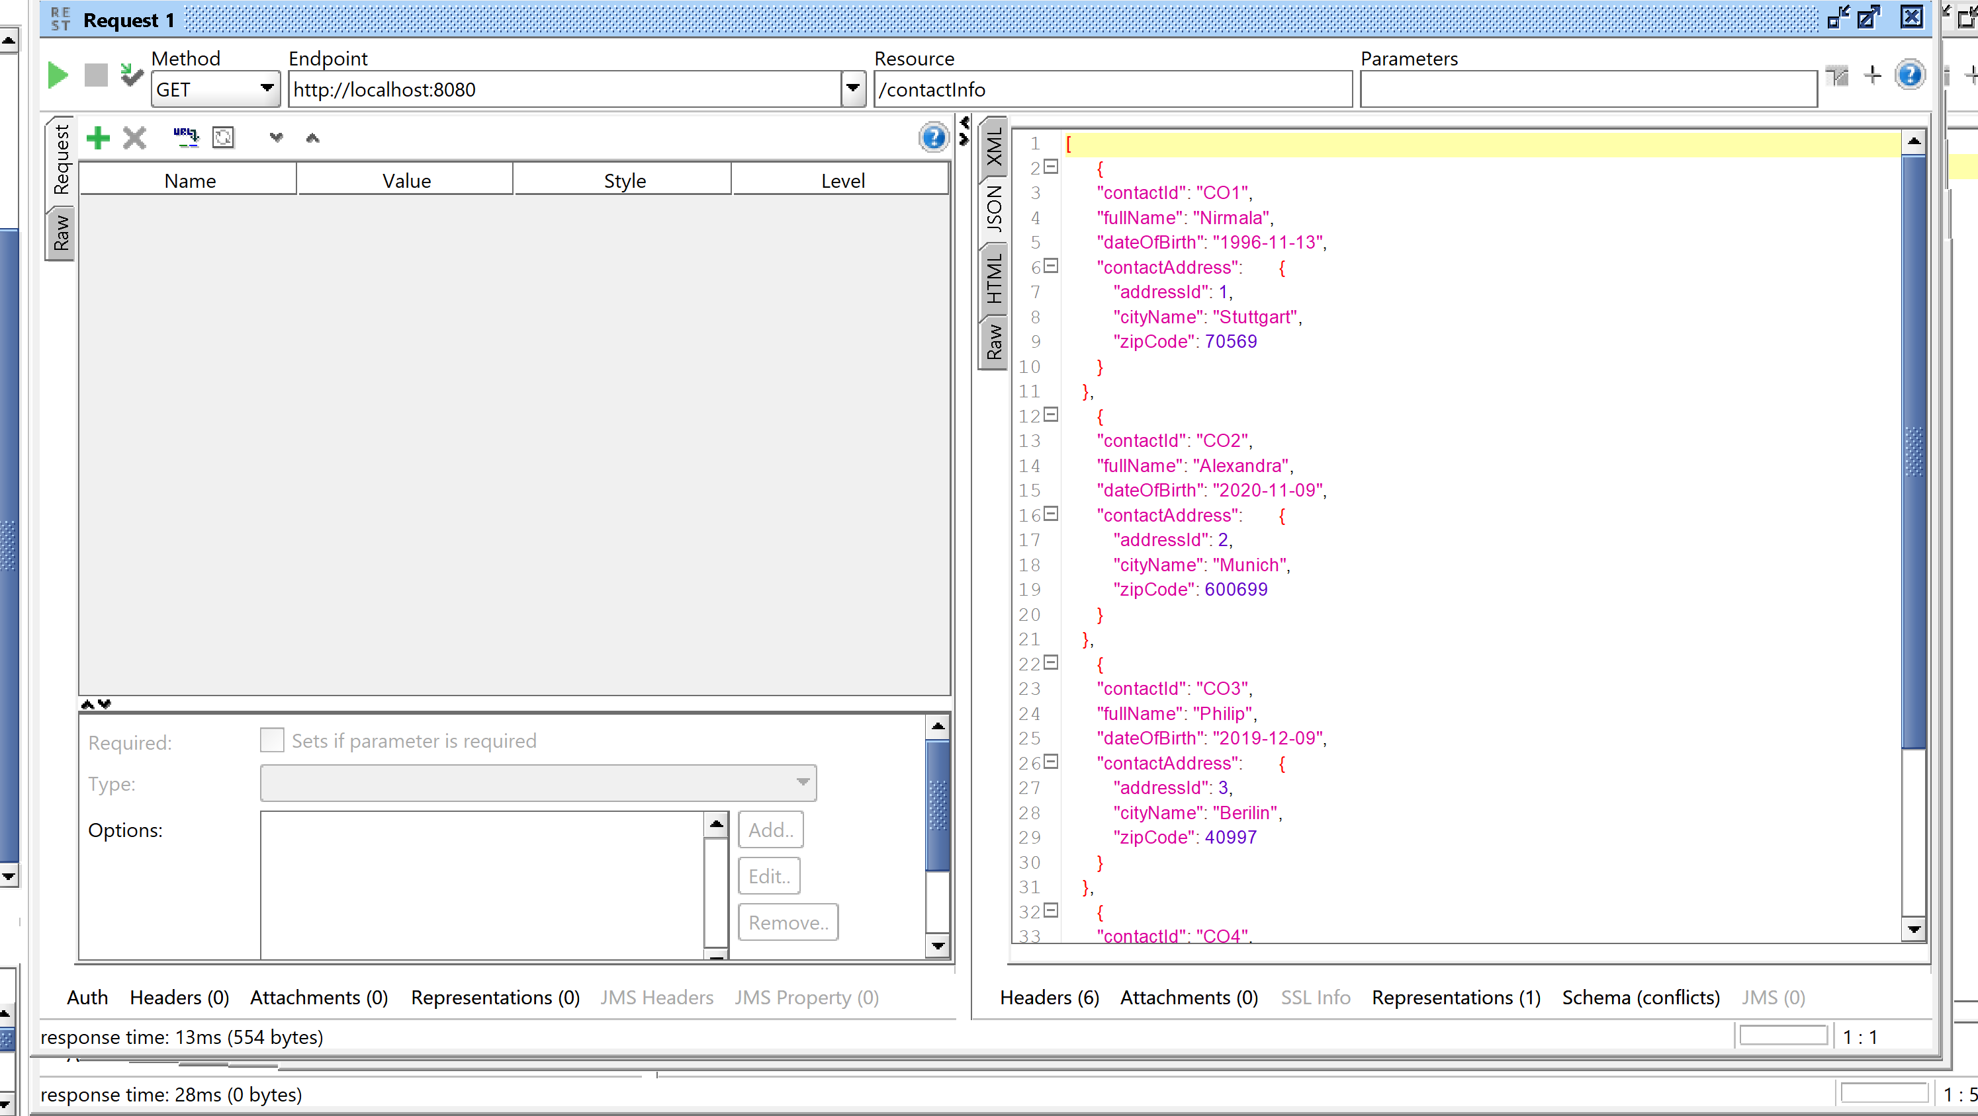

No records in Database

Response status – 204 –No Record

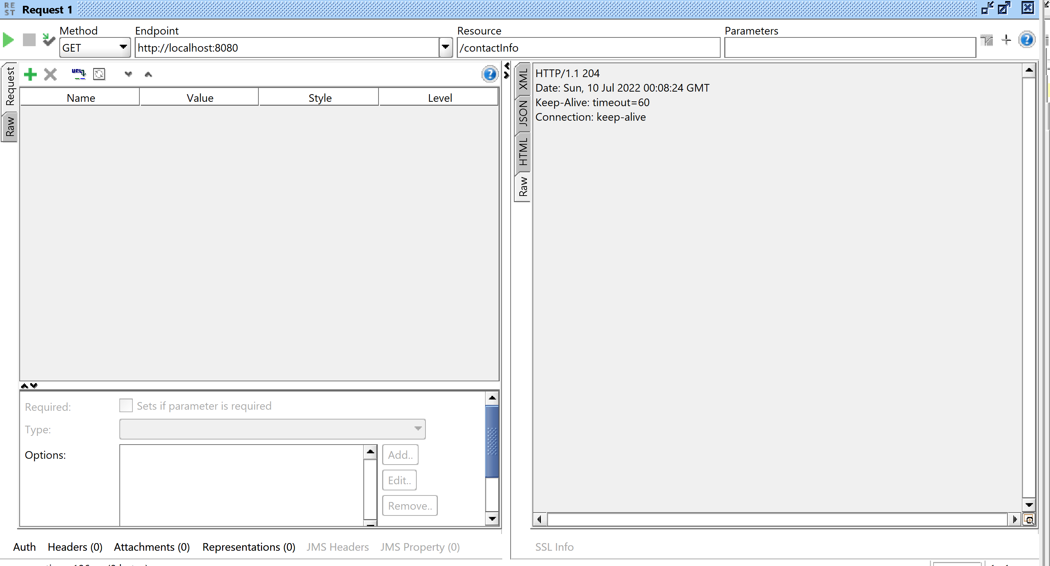

PUT METHOD

Valid request

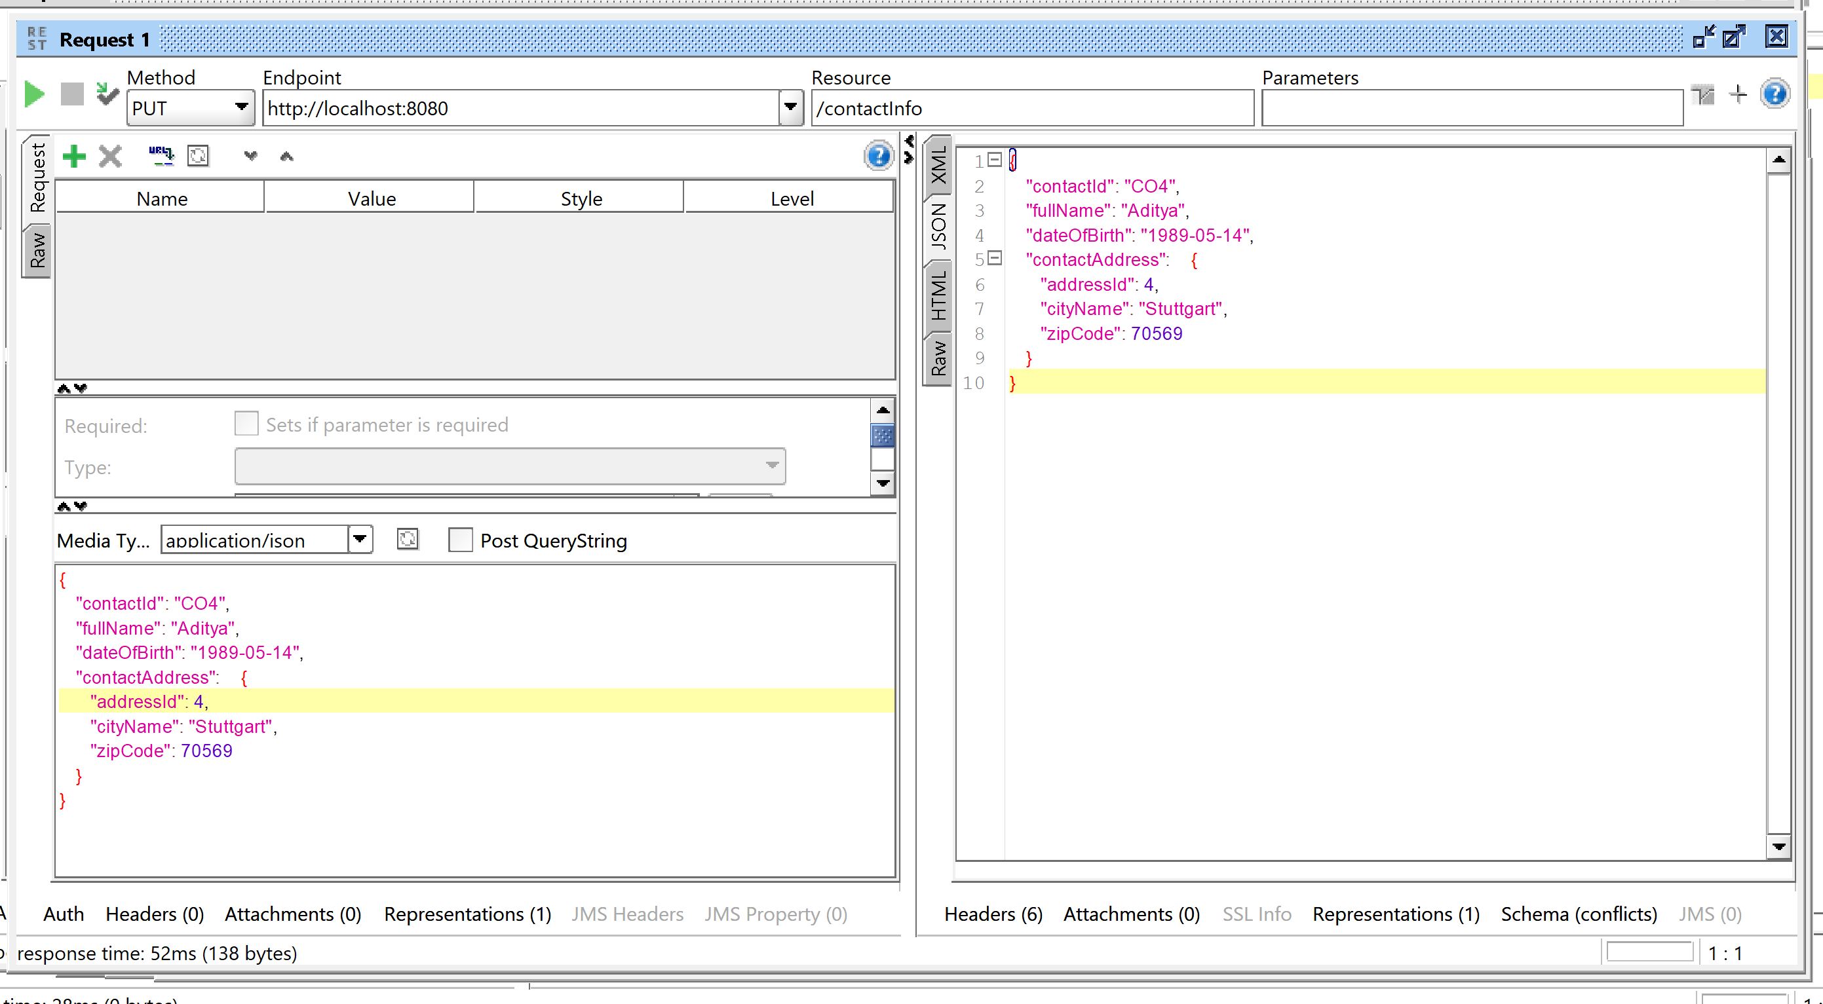

Not valid request with wrong contact Id

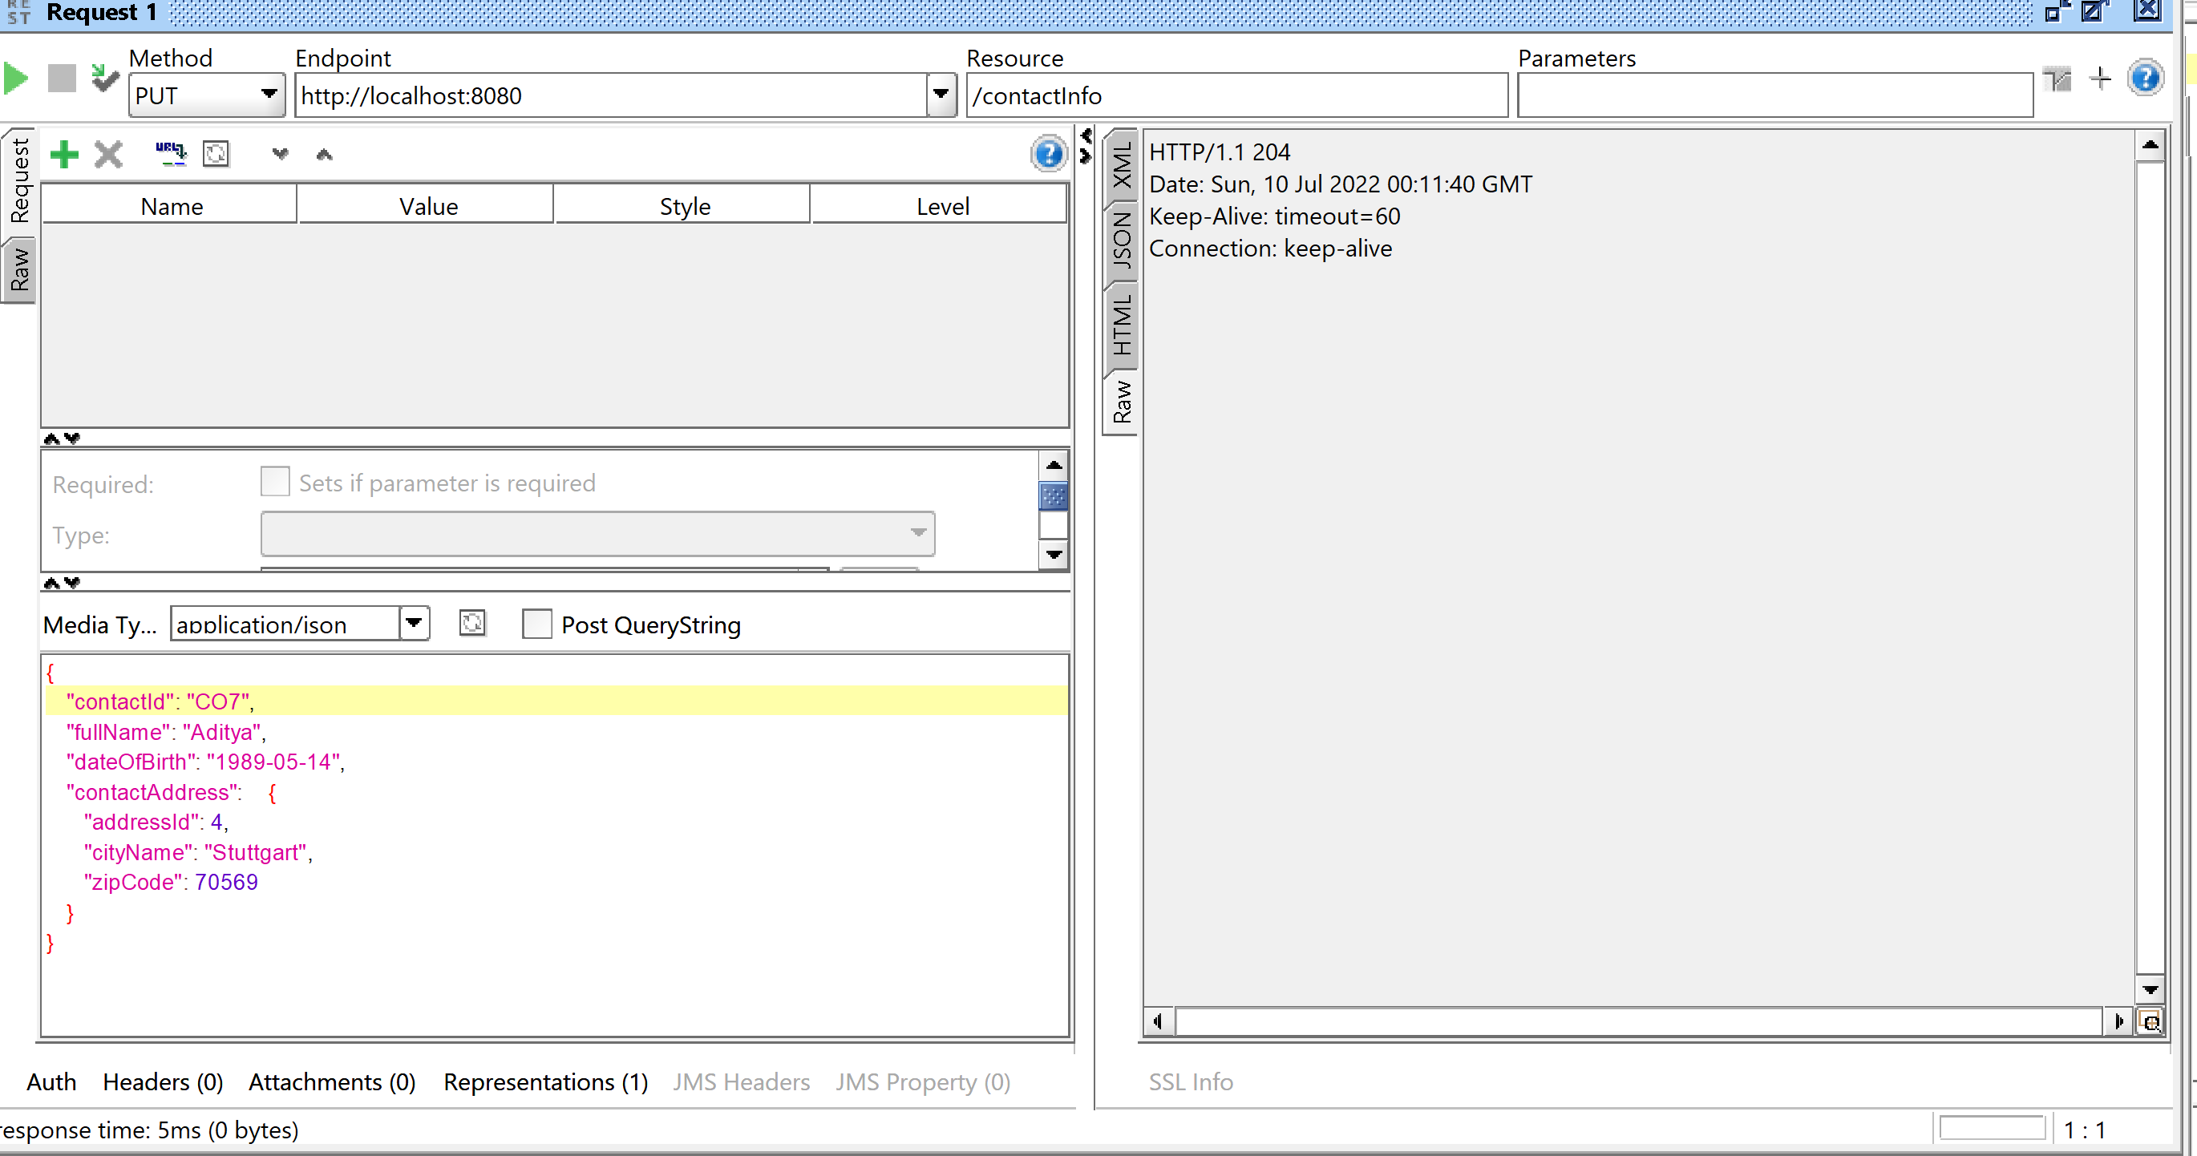

PATCH REQUEST

Valid request

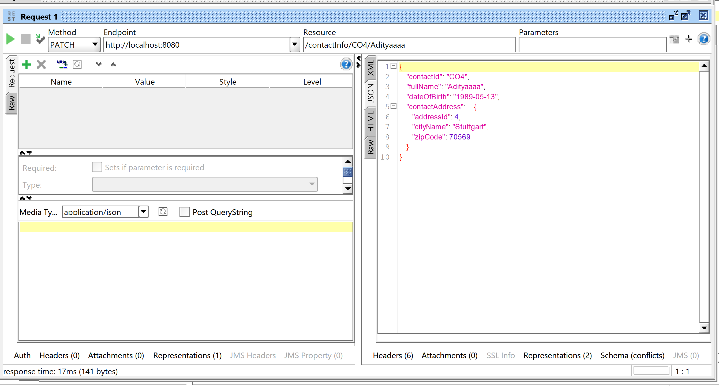

DELETE METHOD

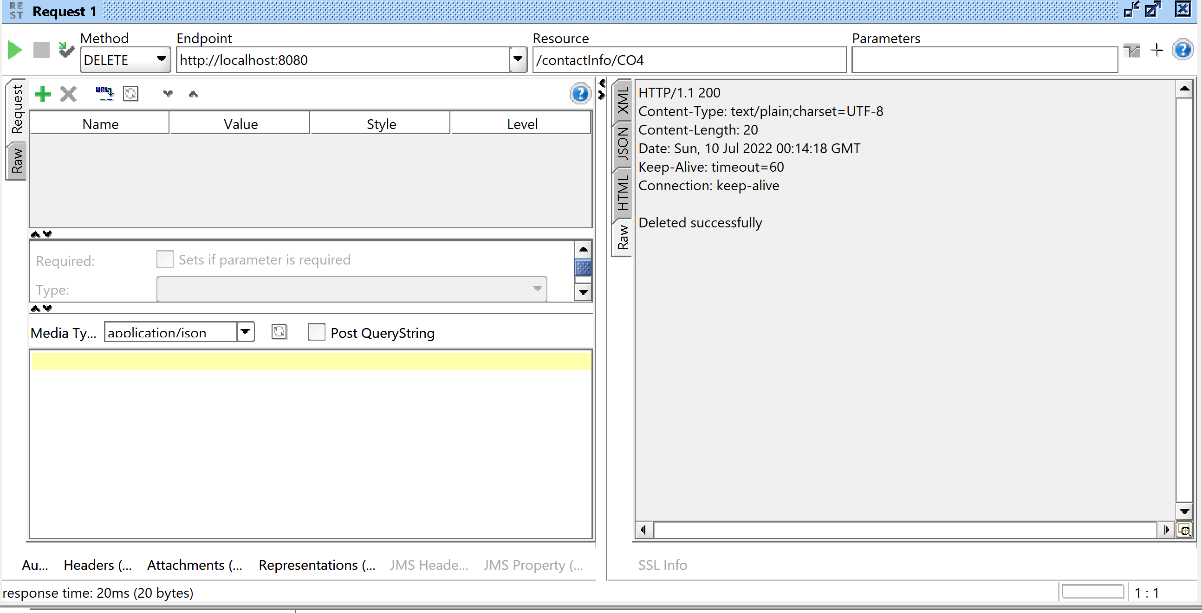

GET METHOD WITH ZIP CODE  
